**Information**

|  |  |  |
| --- | --- | --- |
| **CRIM ID** | **Title** | **Workstream** |
| C0177 | Transfer Project Equipment Into Service | Projects/Service |

**Revision History**

|  |  |  |  |
| --- | --- | --- | --- |
| **Revision** | **Date** | **By** | **Remarks** |
| 0.1 | 11/03/2021 | Simon Testard | Base spec - DRAFT |
|  |  |  |  |
|  |  |  |  |
|  |  |  |  |

# Report Narrative

Group Living Projects contain the equipment demand that needs to be transferred into Service on completion/delivery of an installation site.

A RMB Event at the SubProject level should be available, looking up project demand and Service Object ID to create the required functional objects in IFS.

1. RMB Location should available on the Project Navigator at the Subproject Level:

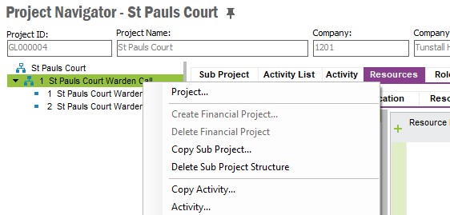

1. RMB Option should only be available if the Subproject’s Object ID has been filled out

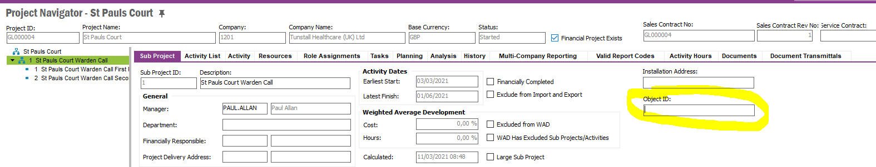

1. RMB Event should look up all Activities that are part of the selected SubProject

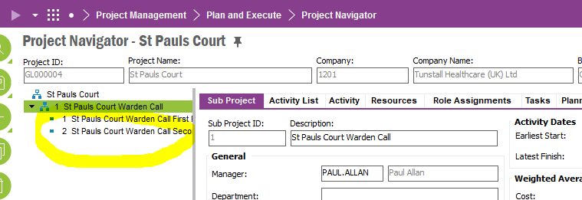

1. For Each Activity, the RMB Event should look up into the Demand/Misc. Parts tab:

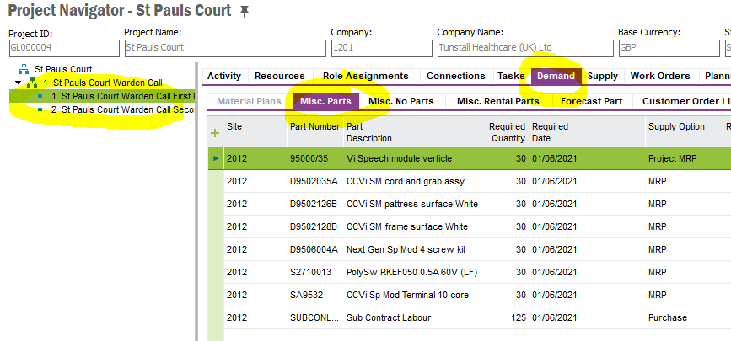

1. For Each Part Number in this tab, the RMB Should lookup whether the part is set as Serviceable

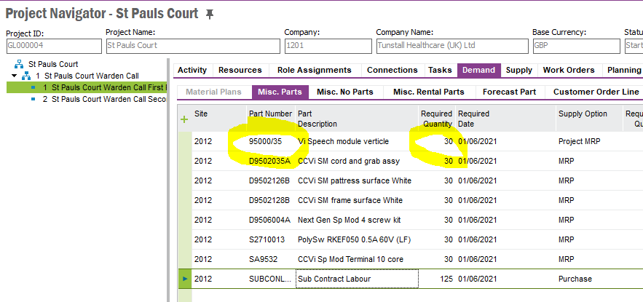

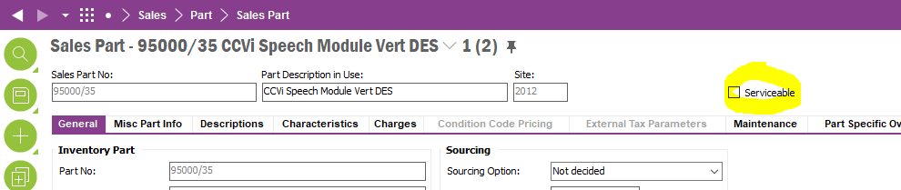

1. RMB Event should aggregate the Quantities of each distinct Serviceable Parts (i.e. Parts where the “Serviceable” tickbox is ticked) from all the activities present under that subproject.

For example, should 95000/35 be set as a Serviceable, and should there be 2 activities for the subproject each requiring a quantity of 30x 95000/35, this would aggregate the quantity of this specific part as 60.

1. RMB event should lookup the Object ID set against the SubProject

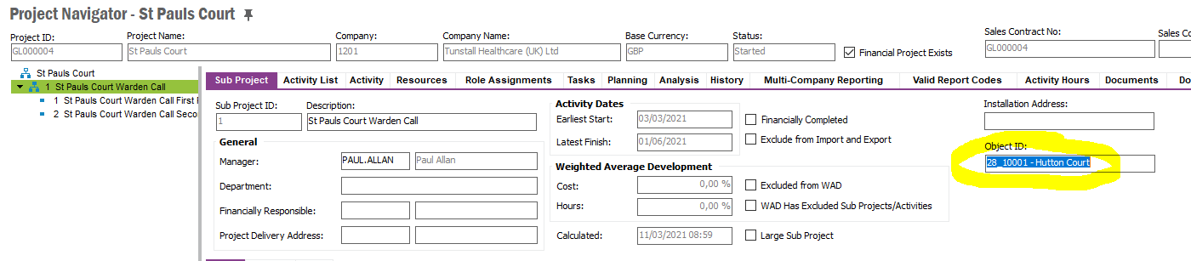

1. RMB event should verify that the Site has been marked as delivered and lookup the Warranty Period for the Site.

This is accomplished by performing a lookup of the Installation Site on the matching Sales Contract.

There should be a Custom Field at the Subproject Level containing the Installation Site. This field is populated when the project is created. [This Field is currently pending creation as part of C0029 Updates. Will only be available once updates to C0029 have been developed]

Lookup the matching Sales Contract’s custom LU “Installation Sites”



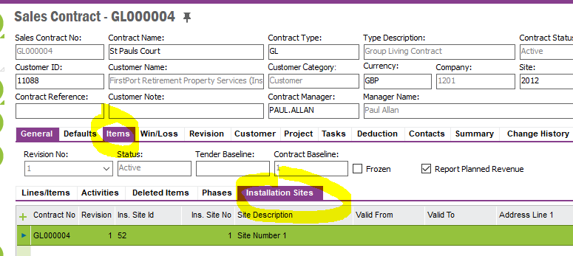

Find the matching Installation Site’s Line. For the sake of example, let’s say the Installation Site that will be recorded on the Subproject is Installation Site No 1

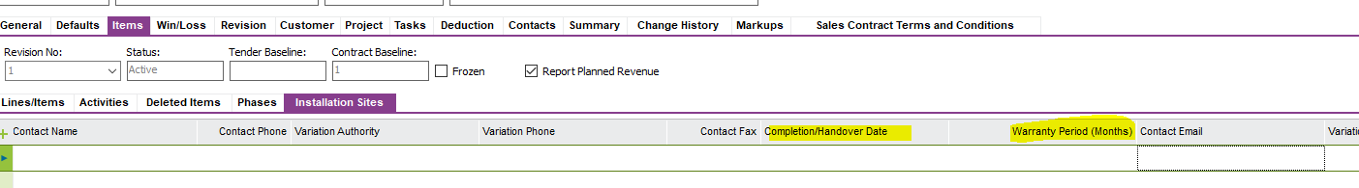

Ensure that the Completion/Handover date has been filled out. Return an error message if it has not and do not process further.

Ensure that Warranty Period (Months) has been filled out. Return an error message if it has not and do not process further.

1. RMB Event should then create functional objects under that Object ID

Below is the list of fields which should be populated by the event based on the information from the Project

1. Part No – Part Number from Misc Parts tab
2. Description – Part Description from Misc Part tab
3. Equipment Quantity – Required Quantity from Misc Part tab (This is the aggregated quantity grouped at the subproject level for that part, as calculated above)
4. Project ID – taken from the project header (project ID field)
5. Sub Project – taken from the sub project (sub project ID)
6. Installation Date – Completion Handover Date from Installation Site
7. Warranty Period – Warranty Period (Months) from Installation Site
8. Belongs to Object – Object ID from Sun Project screen

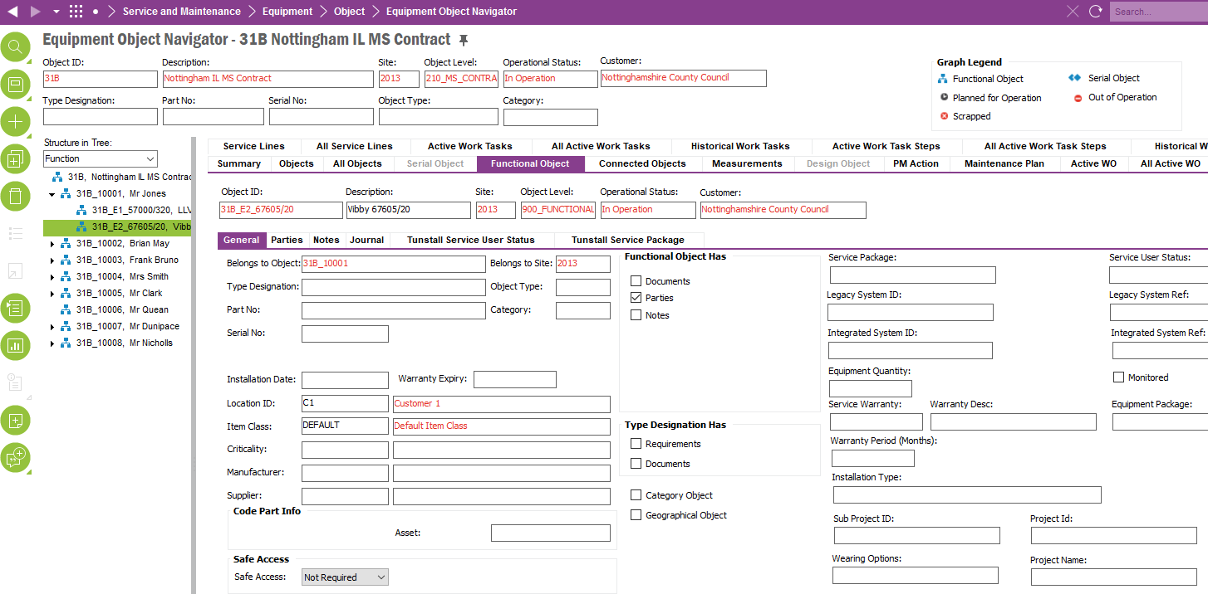

4

5

7

3

6

1

8

2

The Object ID needs to be created based on Part No + Project ID + Sub Project ID.

Other fields to populate by default are:

* Object Site = 2013
* Object Level = 900_Functional_Equipment
* Operational Status = In Operation

# Design Q&A

# BA/Developer Notes/ Related CRIM

# Technical Proposal

*\*\*\*\* Guidance Notes – Remove prior to submission \*\*\*\**

***********************************************

# Technical Solution

## Technical Process

**Window – Project Navigator** Custom Fields –Highlighted Custom Field  
  
 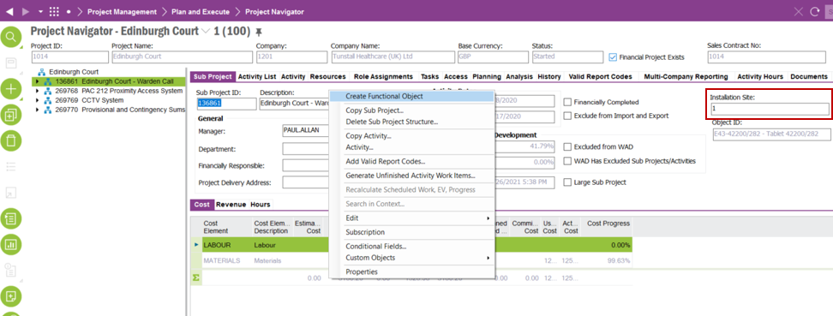

Notes: This is a temporary custom field to store the value of ‘Installation Site’, This is only used of testing purposes until the other CRIM (C0029) is ready.

Custom Menu – Highlighted Custom Menu

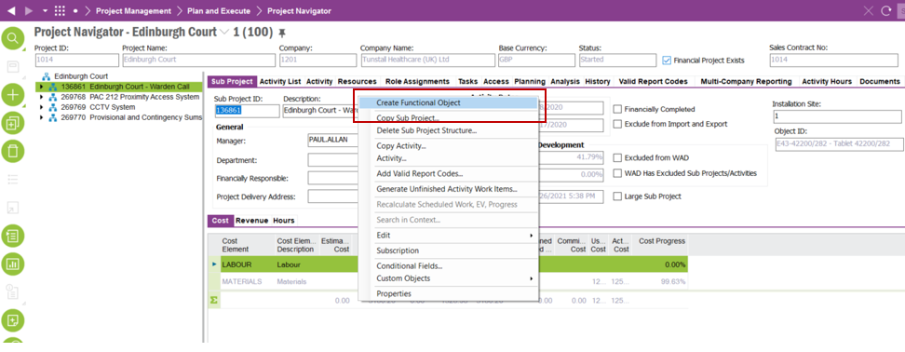

**Permission**All the objects are granted to IFS_ALL  
  
**Database Objects**C_EA_Customization_Util_API. Create_Functional_Object__ : Create the functional objects as per the requirement

***********************************************

## Report Components

********************************************

## Known Dependencies

*\*\*\*\* Guidance Notes – Remove prior to submission \*\*\*\**

***********************************************

# Deployment Instructions

*\*\*\*\* Guidance Notes – Remove prior to submission \*\*\*\**

***********************************************

# Developer Test Proposal

*\*\*\*\* Guidance Notes – Remove prior to submission \*\*\*\**

* *Tests recommended by the developer to be included in UAT*

*e.g.*

| **Test ID** | **Recommended Test** |
| --- | --- |
| 1 | Test the boundaries of all parameters |
| 2 |  |
| 3 |  |
| 4 |  |
| 5 |  |
| 6 |  |
| 7 |  |

***********************************************

# User Acceptance Tests

***********************************************